**DDL Commands – CREATE, ALTER, DROP**

EX NO : 1

AIM:

To Create, Alter and Drop the table using Data Definition Language.

1. Create a table name STUDENT with following structure.

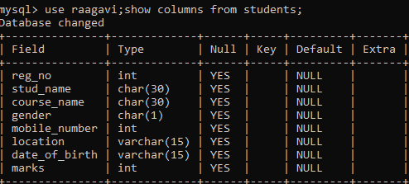

1. Create a table name FACULTY with following structure.

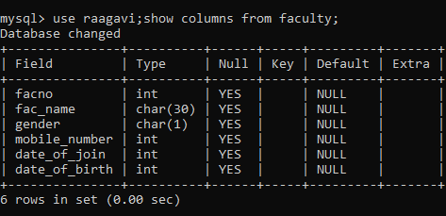

1. Create a table name DEPARTMENT with following structure.

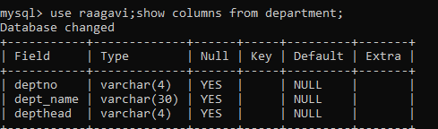

4) Create a table name COURSE with following structure.

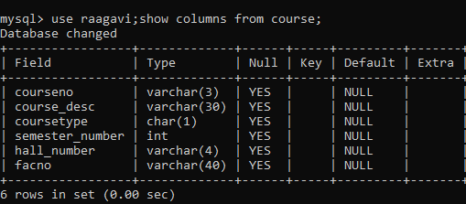

1. Modify the table FACULTY by adding a column name DeptNo of datatype VARCHAR(4)

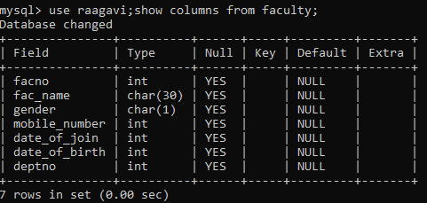

**RESULT:**

Tables are created, altered and modified using DDL commands.